NAME:Rishik JK
REG.NO :192511052

CSA1708-ARTIFICIAL INTELLIGENCE
LAB EXPERIMENT

Experiment 2 – Water Jug Problem

AIM
To write a Python program to solve the Water Jug Problem.

ALGORITHM
- Start with both jugs empty.
- Fill the 4-litre jug completely.
- Pour water from the 4-litre jug into the 3-litre jug.
- Empty the 3-litre jug.
- Pour the remaining water from the 4-litre jug into the 3-litre jug.
- Fill the 4-litre jug again.
- Pour water from the 4-litre jug into the 3-litre jug until it becomes full.
- Now 2 litres of water remain in the 4-litre jug.
- Display the result.

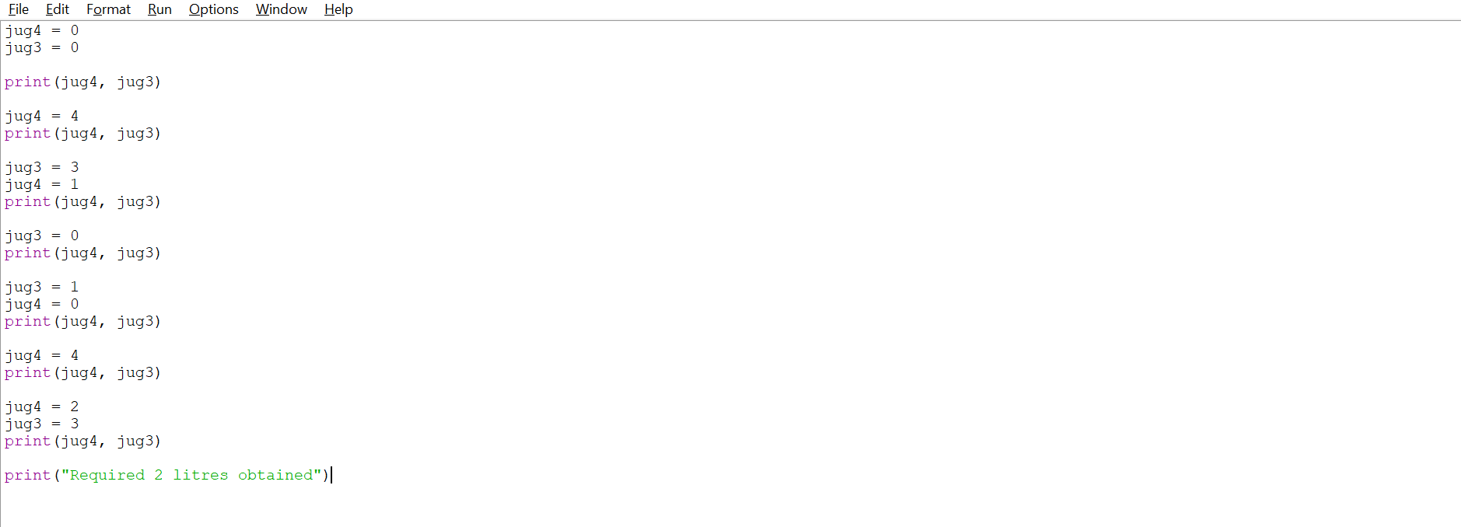

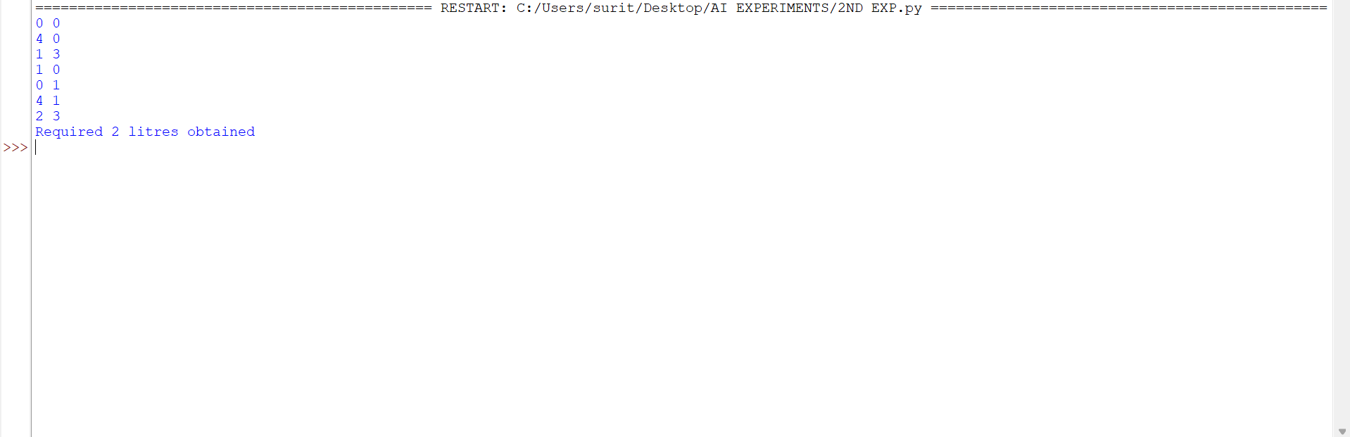

RESULT: Thus, the Water Jug Problem was successfully solved using Python, and the required 2 litres of water was obtained.

